Vector motion - controlling speed
Let’s say we’re working in units of feet and seconds. Speed is define this way:
speed = $\frac{distance travelled}{time it took}$
1. Use the definition of speed above, and your understanding of how vector equations work to do the following:
a). If I’m moving along $f\left(t\right)=t⋅<4, 2>+ <3, 5>$ how fast am I going in feet per second?
b). Modify the equation so I’m going twice as fast along the same linear path
c). Modify the equation so I’m going exactly 1 ft per second along the same linear path
d). Modify the equation so I’m going exactly 10 ft per second along the same linear path

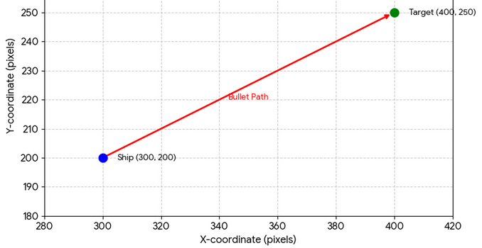
2). My ship is at screen coordinates (300, 200). I’m going to fire a bullet toward the point (400, 250). The bullet travels at a speed of 50 pixels/sec. Write a vector equation for its movement.

3). What about this equation? $\vec{f}\left(t\right)=<-4,2>+t<3,1>+t<1,3>$.
a). First think about what the path really looks like. Sketch it out (think about t = 0, t = 1, t = 2).
b). What’s the speed of travel?
c). If you didn’t do so already, write $\vec{f}(t)$ in the form $\vec{f}\left(t\right)=<-4, 2>+t⋅<____, ____>$. Think about how the new form connects to your picture in a and your speed you calculated in b.

Vector motion - controlling speed – Solutions
1a). If I’m moving along $f\left(t\right)=t⋅<4, 2>+ <3, 5>$ how fast am I going in feet per second?
With each additional second I move along the vector $<4, 2>$, whose length is $\sqrt{20}$. So my speed is $\sqrt{20}$ ft/sec
b). Modify the equation so I’m going twice as fast along the same linear path
If I move along a vector that’s twice as long in the same amount of time I’m going twice as fast. So:
$f\left(t\right)=t⋅<8, 4>+ <3, 5>$ which I could also write as $f\left(t\right)=2t<4, 2>+ <3, 5>$
c). Modify the equation so I’m going exactly 1 ft per second along the same linear path
I want a vector that’s pointed in the same direction as $<4,2>$ but whose length is 1. I’ll divide the vector by its own length to get: $f\left(t\right)=\frac{t}{\sqrt{20}}⋅<4, 2>+ <3, 5>$.
d). Modify the equation so I’m going exactly 10 ft per second along the same linear path
To get this I’ll take my last equation but scale the vector to be longer by 10 so now I’m traveling a length 10 vector that points in the direction I want. $f\left(t\right)=\frac{10⋅t}{\sqrt{20}}⋅<4, 2>+ <3, 5>$

2. My ship is at screen coordinates
(300, 200). I’m going to fire a bullet toward the point (400, 250). The bullet travels at a speed of 50 pixels/sec. Write a vector equation for its movement.
Let’s start with something close:
$$p\left(t\right)=<300, 200>+t⋅<100,50>$$
This starts at the right spot, and moves in the right direction. The problem is that it moves the full distance in 1 second. So let’s scale that vector down to a length of 50. First we’ll scale it down to length 1 by dividing by its length, then we’ll scale it up to a length of 50.
$$p\left(t\right)=<300, 200>+\frac{50t}{\sqrt{1250}}<100, 50>$$

3). What about this equation? $\vec{f}\left(t\right)=<-4,2>+t<3,1>+t<1,3>$
Each second we move along $<3, 1>$ and $<1, 3>$ as shown in the table here. We can simplify this as $\vec{f}\left(t\right)=<-4, 2>+t<4,4>$
$$t$$ | Vector sum | Simplified
0 | $$<-4, 2>$$ | $$<-4, 2>$$
1 | $$<-4, 2>+<3,1>+<1,3>$$ | $$<-4, 2>+<4,4>$$
2 | $$<-4, 2>+2⋅<3,1>+2⋅<1,3>$$ | $$<-4, 2>+2⋅<4,4>$$
3 | $$<-4, 2>+3⋅<3,1>+3⋅<1,3>$$ | $$<-4, 2>+3⋅<4,4>$$

Compare these to the diagram here. You can see the two vectors $<3, 1>$ and $<1, 3>$ (dashed) combine to the vector $<4, 4>$ (solid).

t = 0
t = 1
t = 2
At t = 0: I’m at (-4, 2). I moved along the vector <4,4> whose length is $\sqrt{32}$. So that’s my speed.
We could simplify the original equation this way:
$$\vec{f}\left(t\right)=<-4,2>+<3t,t>+<t,3t>$$
$$\vec{f}\left(t\right)=<-4,2>+<4t,4t>$$
$$\vec{f}\left(t\right)=<-4,2>+t<4,4>$$

Controlling rotational speed
There’s an important difference between speed and rotational speed.
Speed is $\frac{distance}{tme}$, but rotational speed measures how fast your angle changes as you rotate. It’s calculated by $\frac{angle rotated by}{time it took}$. For example: $\frac{10 degrees}{3 seconds}≈3.33 deg/sec$.
1. [C] This problem highlights the difference between speed and rotational speed.
Say I’m moving along a path defined by $g\left(t\right)=3⋅<\cos\left(2t\right),\sin\left(2t\right)>$
a. What’s my angle at t = 0 ? At what time will my angle be $2π$ ?
Put your last two answers together: What’s my rotational speed in radians per second?

b. My speed is different. It’s still measured in ft/sec. Lets’ find it.
How long did it take me to make one full rotation?
What’s the length of that circular path (dig deep, you know this).
Put the last two answers together: What’s my speed in ft/sec?

2. [C] Controlling speed.
a). Keep the circle the same size (radius 3), but make me rotate twice as fast. (write the new vector equation). What’s my rotational speed in radians/sec?

b). If I’m rotating twice as fast, is my speed also twice as fast? Check it.

c). Keep the circle the same size, and make it take 10 seconds for me to complete a circle.
(write the new vector equation)

d). Keep the circle the same size, and make me move at a speed of 5 ft/sec

SOLUTIONS
1. I’m moving along a path defined by $\vec{g}\left(t\right)=3⋅<\cos\left(2t\right),\sin\left(2t\right)>$
a. What’s my angle at t = 0 ? Angle is given by $2t$. At $t=0$ the angle will be 0
At what time will my angle be $2π$ ? I want to find t so that $2t=2π$. Therefore $t=π$
Put your last two answers together: What’s my rotational speed in radians per second?
It takes me $π$ seconds to rotate $2π$ radians (a full circle).
So $rotational speed=\frac{angle rotated by}{time it took}=\frac{2π}{π}=2 radians/sec$
b. My speed is different. It’s still measured in ft/sec. Let’s find it.
How long did it take me to make one full rotation? $π seconds$
What’s the length of that circular path? Circumference = $2πr$. Since r = 3, it’s $6π$
Put the last two answers together: What’s my speed in ft/sec? $\frac{distance traveled}{time it took}=\frac{6π}{π}=6 ft/sec$

2. [C] Controlling speed.
a). Keep the circle the same size, but make me rotate twice as fast.

$$\vec{g}\left(t\right)=3⋅<\cos\left(4t\right),\sin\left(4t\right)>$$
How do I know this works? If you imagine the graph of $A(t)$, angle as a function of time, it’s $A\left(t\right)=4t$.
The slope is 4. Slope represents change in y over change in x. For our graph that’s $\frac{change in angle}{change in time}$ which is exactly rotational speed. Before our rotational speed was $2 rad/sec$ and now it’s $4 rad/sec$ .

b). If I’m rotating twice as fast, is my speed also twice as fast? Check it.
The circumference is still $6π$. If my angle is given by $4t$ then it makes a full rotation in $\frac{2π}{4}=\frac{π}{2}$ seconds.
So my speed is $\frac{6π}{\frac{π}{2}}=12 ft/sec$. Yup, I’m going twice as fast.

c). Keep the circle the same size, and make it take 10 seconds for me to complete a circle.
I want it so that it takes 10 seconds to rotate by $2π$ radians. So: $\frac{2π radians}{10 seconds}$ is my rotational speed. Therefore the equation is: $\vec{g}\left(t\right)=3⋅<\cos\left(\frac{π}{5}t\right),\sin\left(\frac{π}{5}t\right)>$
d). Keep the circle the same size, and make me move at a speed of 5 ft/sec
If you don’t see a solution idea, you can always try and solve for the thing you want. We want to change the rotational speed so that our actual speed is 5 ft/sec. Let’s name the rotational speed M for mystery.
$\vec{g}\left(t\right)=3⋅<\cos\left(M⋅t\right),\sin\left(M⋅t\right)>$. I know M affects how long it takes to make a full rotation. And that affects my speed. So let’s figure those bits out…
How long will it take to make a full rotation? $M⋅t=2π$ means $t=\frac{2π}{M}$. A full rotation is still a distance of $6π$.
So my speed must be: $\frac{distance travelled}{tme it took}=\frac{6π}{\left(\frac{2π}{M}\right)}=6π⋅\frac{M}{2π}=3M$ .
I want my speed to be 5. SO: $3M=5$ $M=\frac{5}{3}$

You can also work out the above just by thinking about proportions. I travel $6π$ feet for every $2π$ radians I rotate. That makes $\frac{6π ft}{2π rad}=3 ft/rad$. Flipping it, that means I’ll rotate $\frac{1}{3}rad$ for each foot I travel. If I were going 1 ft per second, that would mean $\frac{1}{3}$ rad per second. If I want to go 5 ft per second, that means I must go $\frac{5}{3}$ rad per second.

Putting it all together to solve some problems
1). I walk a path $\vec{m}\left(t\right)=<-5,-2>+t⋅\frac{1}{7}<1,4>$
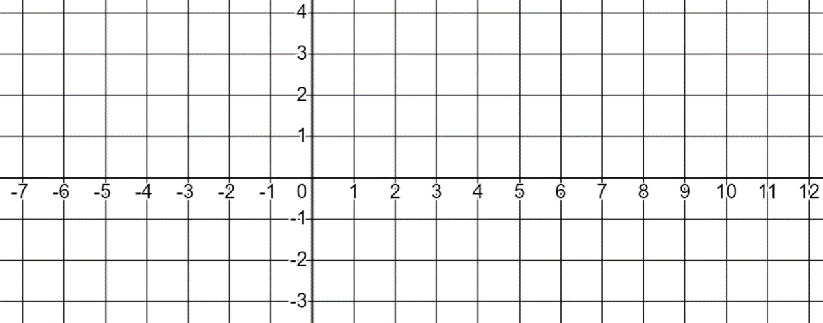
My friend walks directly left along $\vec{f}\left(t\right)=<10, 3>+t<-1,0>$

a). Find the (x, y) coordinates where my path crosses my friend’s path.
b). Adjust my speed so I’ll bump into my friend. (in other words, we’ll be in the same location at the same time). Re-write the equation for $\vec{m}$
Hints
Can you set up equations that let you solve for what you want?
Write all the information you know
What do you want to know?
Could you write what you know in a different way that’s more helpful?

2). I have a robotic dog that moves along the path $\vec{v}\left(t\right)=<5, 7>+2⋅<\cos\left(\frac{π}{2}-πt\right),\sin\left(\frac{π}{2}-πt\right)>$
I start at the point (20, 30) at t = 0 and walk in a straight line so that I meet up with the dog at t = 51.
Find the vector equation for my linear movement.

Putting it all together to solve some problems – Solutions
I walk a path $\vec{m}\left(t\right)=<-5,-2>+t⋅\frac{1}{7}<1,4>$
My friend walks directly left along
$$\vec{f}\left(t\right)=<10, 3>+t<-1,0>$$
a). Find the (x, y) coordinates where my path crosses my friend’s path.
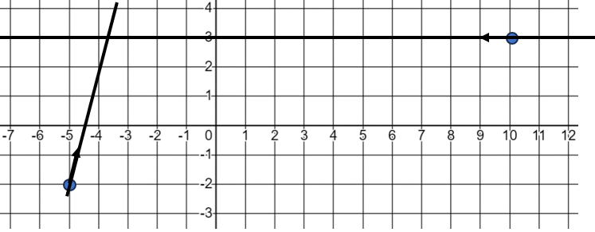
Where’s that point of intersection? One thing we could do is find the cartesian equation for both lines and solve for the point of intersection.
The top line is $y=3$ the bottom line is $y=$ $4\left(x+5\right)-2$. Solving for x we get $3=4\left(x+5\right)-2$ $3=4x+18$ $\frac{-15}{4}=x$ . That makes the point of intersection $\left(\frac{-15}{4},3\right)$
A different way to do it would be figure out the time at which $\vec{m}(t)$ has a y coordinate of 3. Let’s do that. The equation for just the y coordinate would be $y\left(t\right)=-2+\frac{4}{7}t$ . Solve for y = 3.
$3=-2+\frac{4}{7}t$ $5=\frac{4}{7}t$ $\frac{35}{4}=t$ .
Now we can plug that time in and find the x-coordinate.
$x\left(t\right)=-5+\frac{1}{7}t$ . So $x\left(\frac{35}{4}\right)=-5+\frac{1}{7}⋅\left(\frac{35}{4}\right)=-5+\frac{35}{28}=\frac{-140 + 35}{28}=\frac{-105}{28}=-3.75$ which is $\frac{-15}{4}$ as before.

b). Adjust my speed so I’ll bump into my friend. Re-write the equation for $\vec{m}$
To do this, we’ll need to know when my friend is at the location in part a.
My friend’s x coordinate is given by $x\left(t\right)=10-t$ . If I want an x coordinate of $-\frac{15}{4}$ that means $-\frac{15}{4}=10-t$ $t=10+\frac{15}{4}$ or $t=\frac{55}{4}$ . So I need to change my speed so that I hit a y coordinate of 3 at exactly $t=\frac{55}{4}$ .
One way to do it is to think: Right now I get there at $\frac{35}{4}$ . I need to get there at $\frac{55}{4}$ . So how much do I need to scale my speed by? $\frac{\left(\frac{35}{4}\right)}{\left(\frac{55}{4}\right)}=\frac{35}{55}=\frac{7}{11}$.
That would give my new equation as $\vec{m}\left(t\right)=<-5,-2>+t⋅\frac{1}{7}⋅\frac{7}{11}<1,4>$ which is $\vec{m}\left(t\right)=<-5,-2>+t⋅\frac{1}{11}<1,4>$
Alternatively, you can always solve for the thing you don’t know. Let’s call our scale factor M for mystery.
$$\vec{m}\left(t\right)=<-5,-2>+t⋅M<1,4>$$
Looking a y-coordinates only: $y\left(t\right)=-2+4t⋅M$ . Plugging in the time and y-value I want: $3=-2+4\left(\frac{55}{4}\right)M$ . Solve for M: $\frac{5}{4}=\frac{55}{4}M$ $\frac{5}{55}=M$ so $M=\frac{1}{11}$ as before.

2). I have a robotic dog that moves along the path $\vec{v}\left(t\right)=<5, 7>+2⋅<\cos\left(\frac{π}{2}-πt\right),\sin\left(\frac{π}{2}-πt\right)>$. I start at the point (20, 30) at t = 0 and walk in a straight line so that I meet up with the dog at t = 51. Find the vector equation for my linear movement.
Let’s find where the dog is at t = 51. $\vec{v}\left(51\right)=<5,7>+2⋅<cos\left(\frac{π}{2}-51π\right), sin\left(\frac{π}{2}-51π\right)>$
The angle is $\frac{π}{2}-51π$ . Where is that? If it were just $-51π$ I’d be here. You can literally count up how many $π$’s. Every rotation by an odd number of $π$ will end up at a location coterminal with $π$ on the left side of the circle.
However, we’re at $\frac{π}{2}$ more than that. So our real location is:

That means $sin\left(\frac{π}{2}-51π\right)$ is -1 and $cos\left(\frac{π}{2}-51π\right)$ is 0. That makes the dog’s location: $(5, 5)$.
I want to start at (20, 30) at t = 0 and end at (5, 5) at $t=51$. Let’s sketch it:
(20,30)
(5,5)
As a vector equation I could write:
$\vec{f}\left(t\right)=<20,30>+t⋅M<-15,-25>$ where M controls my speed.
What should M be? Let’s solve using just the x coordinates.
$$x\left(t\right)=20-15⋅t⋅M$$
I know at t = 51 I want x to be 5. SO: $5=20-15⋅51⋅M$ $-15=-15⋅51⋅M$ $\frac{1}{51}=M$
$$\vec{f}\left(t\right)=<20,30>+t⋅\frac{1}{51}<-15,-25>$$

